Implementation Specification
for
Product Curation Tool Version 3.2 Release 0

Last Updated: September 21, 2006

Owner: Sumana Hegde
Telephone: 972-437-5001
Email: shegde@scenpro.com

National Cancer Institute Center for BioInformatics
6116 Executive Blvd.
Rockville, MD 20852



1 Document Purpose 4
2 Implementation Overview 5
2.1 Team Members 5
2.2 Description 5
2.3 Scope 5
2.4 Architecture 6
2.5 Assumptions 9
2.6 Dependencies 9
2.7 Issues 9
2.8 Third Party Tools 10
3 Implementation Contents 11
3.1 Server 11
3.1.1 Algorithms 11
3.1.2 Batch Processes 13
3.1.3 APIs 13
3.1.4 Error Handling 13
3.1.5 Database Changes 13
3.2 Client 14
3.2.1 JSP/HTML 14
3.2.2 Servlet 14
3.2.3 Error Handling 14
3.3 Security Issues 14
3.4 Performance 15
3.5 Internationalization 15
3.6 Installation / Packaging 15
3.7 Migration 15
3.8 Documentation Considerations 15
4 Unit Testing 16
4.1 Test Guidelines 16
4.2 Test Cases 16
4.3 Test Results 16
DOCUMENT CONTROL 17
DOCUMENT APPROVAL 18

List of TABLES
Table 1 – Team Members 5
Table 2 - Extended Value Meaning Table in caDSR to make it an Administered Component 8
Table 3 - Third Party Tools 9
Table 4 – Implementation Specification Document Change Log 15
Table 5 - Test Plan Approvers List 16
Table 6 - Test Plan Reviewers List 16

LIST OF FIGURES

Figure 1 -Class Diagram for gov.nih.nci.cadsr.cdecurate.tool package 7
Figure 2 - Class Diagram for gov.nih.nci.cadsr.cdecurate.test package 8
Figure 3 - User Interface for Value Meanings 13

Document Purpose

This document details changes to Value Meanings in the caCORE 3.2 Curation Tool. The Curation Tool general Architecture Design exists in a separate document. The User Requirements for the Curation Tool in 3.2 exists in a separate Requirements document. This implementation document assumes the reader is familiar with these related documents.

The document’s primary purpose is to assist in the development process and aid in the review and maintenance of the design and code. The intended audience is primarily designers, developers, testers and technical writers as such NCICB and computer industry standard abbreviations and terms are used. Should a term be ambiguous or deviate in any way from its’ standard use, an explanation is provided for clarification.

This document will be maintained during the project to log decisions made as the project progresses.

Implementation Overview

Team Members
Table 1 – Team Members
Role | Name
Development Lead | Larry Hebel
Documentation Lead | Sumana Hegde
Program Manager | Jennifer Brush
Test Lead | Robert Harding

Description
The Curation Tool provides the ability to create and edit Value Meanings through Permissible Values on a Value Domain. In this release Value Meanings are expanding to include Long Name, Workflow Status, Context, and Version. This is the first step to making the Value Meanings an Administered Component with completion planned for caCORE 4.0.

Value Meanings may exist without association to EVS Concepts or with an association to one or more EVS Concepts. CDE Curators will be given appropriate editing features to manage the Value Meaning and these Concept associations. Following is the list of known scenarios for creating or updating the Value Meanings.

- Update an existing Value Meaning with a EVS Concept code from EVS
- Update an existing Value Meaning with two or more EVS Concept codes from EVS
- Create a new Value Meaning using one or more EVS Concepts
- Create a new Value Meaning without selecting Concepts from EVS
- Edit an existing Value Meaning: Add new EVS Concept(s)
- Edit an existing Value Meaning: Remove EVS Concept(s)
- Edit an existing Value Meaning that is not associated to one or more EVS Concepts
- Remove all EVS Concepts from an existing Value Meaning

A separate Use Case document details each.

When the EVS Concept relationship is changed it will also reset the Value Meaning Begin Date to the current date.

Scope
The implementation of Value Meaning affects the follow areas.

- gov.nih.nci.cadsr.cdecurate.tool
The internal classes and user interface management providing the logic within the Curation Tool source codes.
- gov.nih.nci.cadsr.cdecurate.test
The automated and manual tests for the Curation Tool.
- User Interface
The JSP changes necessary to provide the CDE Curator with necessary Value Meaning editing capabilities.
- Oracle caDSR API
The database packages providing search, create and update capabilities SBREXT.SBREXT_CDE_CURATOR_PKG, SBREXT.SBREXT_SET_ROW and SBREXT.SBREXT_GET_ROW.
More detail on each follows.

Architecture
Curation Tool uses a Model-View-Controller (MVC) architecture consistent with the caCORE 3.1 implementation. Changes for Value Meanings do not impact the Curation Tool fundamental architecture. Details for the affected areas follow.

- gov.nih.nci.cadsr.cdecurate.tool
Class changes include VMServlet, VMAction, VMForm and VM_Bean as shown in the following diagram.

Figure 1 -Class Diagram for gov.nih.nci.cadsr.cdecurate.tool package
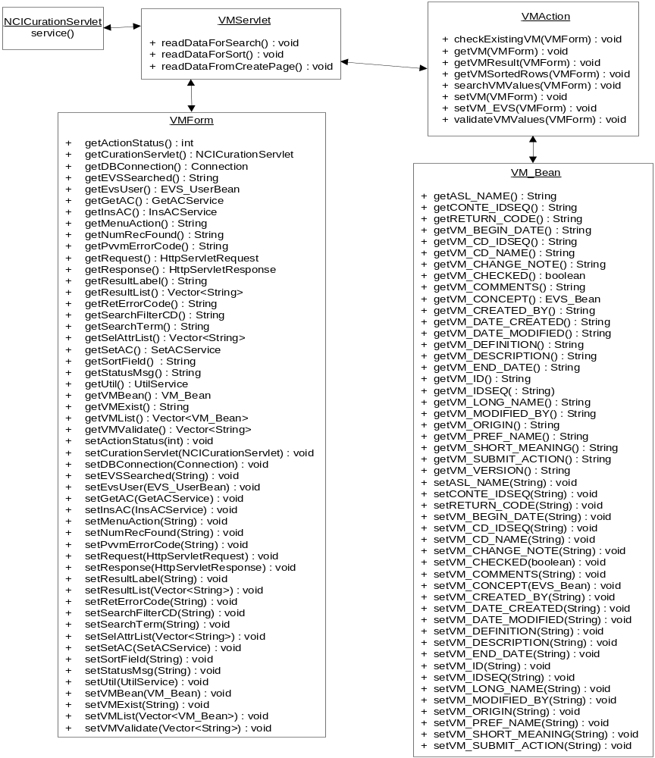

NCICurationServlet
The service() method forwards Value Meaning requests to the VMServlet class.

VMServlet
The request from the JSP page will be stored in a VMForm object and passed to the VMAction class. This class also sets the data back into request or session objects as needed.

VMForm
The JSP form data.

VMAction
The request is interpreted and processed according to the use cases noted above (see section 2.2). The process first determines the scenario in which the request is made, e.g. associating an EVS Concept to a Value Meaning which has no associations. Next the process validates the data according to the business rules noted below. Finally the user may be asked to confirm the change, the user is informed the change can not be made or the change is made without additional input from the user. The current state of the Value Meaning is persisted in a VM_Bean class object for eventual updates to the database.

VMBean
The Value Meaning attributes from the database.

- gov.nih.nci.cadsr.cdecurate.test
A new test class will be added to the package as follows.

Figure 2 - Class Diagram for gov.nih.nci.cadsr.cdecurate.test package
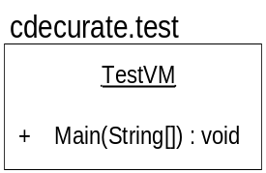

TestVM
This test uses an XML configuration file to control the nature of the Value Meaning test. Database changes are limited to the TEST Context due to the destructive behavior of the required tests. Value Meaning data will change and must not impact Production related data. Further, prior to executing the tests, the database must be seeded with known states, again in the TEST Context. These tests are not permitted in any other Context.

- gov.nih.nci.cadsr.cdecurate.tool
User Interface components are stored in the project “/ui” folder. Affected files include PermissibleValue.jsp, Create_VD.jsp, Edit_VD.jsp, SearchParameter.jsp and SearchResults.jsp.

PermissibleValue.jsp
Provides the user with Value Meaning Create and Edit interfaces.

Create_VD.jsp and Edit_VD.jsp
Value Meanings appear with Permissible Values for a Value Domain.

SearchParameter.jsp and SearchResults.jsp
Provides a search for existing Value Meanings from caDSR, SearchParameter.jsp contains filter parameters and SearchResults.jsp contains the search results.

- Oracle APIs
The Sbrext.sbrext_cde_curator_pkg.Search_vm stored procedure is modified to return additional attributes as described above (see section 2.2). Sbrext.sbrext_cde_curator_pkg.set_vm will create a new Value Meaning and Sbrext.sbrext_cde_curator_pkg.get_vm will get the existing Value Meaning. Details on the table and view changes for Value Meanings can be found in the caDSR Model changes.

Assumptions
Extended Value Meaning table and Value Meaning view will contain the additional attributes needed for 3.2. The Value Meaning long name will be identical to the “short meaning” in 3.1. The long name must be unique and is retained as the primary key. Propagation of the generated value, VM_IDSEQ, as the primary key will not be done until caCORE 4.0.

The following business rules apply.

- A Value Meaning long name can not be null.
- A Value Meaning definition (description) can not be null.
- A Value Meaning long name must be unique, see previous paragraph.
- A Value Meaning with associations to EVS Concepts will be named by concatenating the Concept names and will have a definition from concatenating the Concept definitions.
- A Value Meaning long name and definition can not be changed by the Curator once associated to EVS Concepts. A companion to the previous rule.
- A Value Meaning long name and definition can be changed by the Curator when no associations to EVS Concepts exist.
- An existing Value Meaning is referenced when the definition and long name match a Value Meaning being changed or created.
- An existing Value Meaning is referenced when the associated concepts match a Value Meaning being changed or created.
- Associating EVS Concepts to a Value Meaning which has none applies to all references of the Value Meaning provided the long name does not change.
- Failing to find a matching Value Meaning by long name, definition or associated Concepts will create a new Value Meaning.

Dependencies
caDSR 3.2 database model/schema.

Issues
Requirements for EVS Synonym references have not be determined or defined by the Curators.

The Value Meaning integrity is directly related to changes occurring in EVS. To associate a Value Meaning to EVS Concepts, the caDSR stores a copy of the Concepts for reference. Situations have occurred where EVS content is changed for a concept code after it has been referenced by and copied to the caDSR. This results in confusion among the Curators because the concept name and/or definition as seen from the caDSR will no longer match the values seen when browsing EVS and the Curation Tool will reference the caDSR copy with a successful match on the concept code. This symptom occurs for Object Class, Rep Terms and Value Meanings. Separate processes and business rules need to be developed to address possible conflict resolutions between the EVS Concept preferred names and definitions and the caDSR concept based upon it. EVS assures existing concept preferred name and definition changes do not impact their semantics. These changes can impact human understanding and cause confusion. Also, curators sometimes prefer to use an alternate definition or synonym for the caDSR concept, this is not supported for Value Meanings.

One reason the current process was implemented was to protect the caDSR content from changes in EVS. Once a Concept is used in the caDSR, it can not change without appropriate Curator review, e.g. a Data Element Concept will be used on multiple Data Elements as a result of the Concept associations determined by the Concept name and definition. If either the name or definition change the Data Element Concept can not automatically update. The business rules contain guidelines for versioning an Administered Component based on the changes made. This scenario must still be considered in any attempt to resolve the conflicts between the caDSR and EVS Concepts.

Third Party Tools
The implementation requires the following JAR files. These are necessary to use the caCORE API to access EVS, to access the caDSR and to log runtime exception, error, information and debug messages. These same files are needed for the WAR deployment and the automated tests. Some of these may already be included on the Java classpath.

Table 2 - Third Party Tools
JAR | Release
cglib-full-2.0.1.jar | 2.0.1
client.jar | 3.2
Hibernate3.jar | 3.0.2
log4j.jar | 1.2.8
ojdbc14.jar | Oracle 9i
spring.jar | 1.2
.

Implementation Contents

Server
In this release, Value Meaning table will be extended and a new Value_Meaning_view will be created. Oracle APIs correlated with the schema change will be modified. Logic to get and set the Administered Components’ attributes of the Value Meaning and creating Value Meanings using multiple EVS Concepts will be changed.

Algorithms
Several foundation algorithms are used to support the business rules algorithms. The foundation algorithms are presented first and referenced later as needed.

- Determine the original Value Meaning state prior to changes. An original state could be “NULL” to indicate the Value Meaning did not exist and the Curator intends to create one, “No EVS Concepts” to indicate the Value Meaning exists and has no associations to EVS Concepts and “EVS Concepts” to indicate the Value Meaning exists and has associations to EVS Concepts.
A “NULL” Value Meaning by definition can not exist. Once the Curator submits a Value Meaning it must be in one of the states “No EVS Concepts” or “EVS Concepts” to be validated. Whether or not a Value Meaning is created depends on the validation and as needed additional input from the Curator.
- Verify the long name and definition is not null. Business Rules require values for both whether software generated through the selection of EVS Concepts or Curator entered when no EVS Concepts are selected.
- Find a Value Meaning with matching EVS Concepts. The match can only occur if the concepts count is greater than zero and the concepts count and concepts order are identical.
- Find a Value Meaning with a matching definition. The match is case insensitive and can only occur if the length and content are identical.
- Find a Value Meaning with a matching long name. The match is case insensitive and can only occur if the length and content are identical.
- Find a Concept with a matching definition. The match is case insensitive and can only occur if the length and content are identical.
- Find a Concept with a matching long name. The match is case insensitive and can only occur if the length and content are identical.
- Find all Value Domain references to this Value Meaning ignoring the Value Domain viewed by the Curator. As mentioned earlier the Curator maintains a Value Meaning from the Permissible Values of a Value Domain. This requires the Curator to find a Value Domain referencing the Value Meaning of interest.

The following business algorithms refer to the previous foundation algorithm item numbers for clarity. In all cases item 2 is performed. If either the long name or definition is null the Curator is informed and processing stops until the error is corrected or the Curator cancels the process.

When the Curator searches for and uses an existing Permissible Value or Value Meaning, no validations are required. The foundation algorithms detailed above do not apply. The Value Meaning may be found using terms in the long name and definition or by selecting EVS Concepts.

Following is the algorithm to process a submitted Value Meaning which has no EVS Concept associations. The Curator may have entered the Value Meaning without searching EVS or may have removed all associated EVS Concepts.

- Search for a matching Value Meaning using items 4 and 5 above. If any match is found, note the duplicate.
- Search for a matching Concept using items 6 and 7 above. If any match is found, note the duplicate.
- If a matching Value Meaning and Concept is found, inform the Curator a search for existing must be done or change the Value Meaning again.
- If a matching Value Meaning is found, ask the Curator to confirm the reference or cancel and change the Value Meaning again.
- If a matching Concept is found, ask the Curator to confirm the reference or cancel and change the Value Meaning again. Confirming the reference will create a new Value Meaning using the Concept.
- If a match is found and the Curator confirms the reference then use the Value Meaning. This does not alter the original Value Meaning it alters the Permissible Value reference from the Value Domain to a Value Meaning.
- If no match is found, create a new Value Meaning.

Following is the algorithm to process a submitted Value Meaning which has EVS Concept associations. The Curator may have added and/or removed EVS Concepts repeatedly.

- When the original state of the Value Meaning is “No EVS Concepts”.
  - Search for a matching Value Meaning using item 3. If any match is found, note the duplicate.
  - Search for a matching Value Meaning using items 4 and 5 and excluding the Value Domain viewed by the Curator. If any match is found, note the duplicate.
  - Search for a reference to the Value Meaning from a Form and if found, note the reference.
  - Compare the original Value Meaning long name and the new long name. If they do not match, note the difference.
  - If any “notes” exist from the previous steps, form an appropriate message and ask the Curator to confirm to proceed or cancel to make additional changes to the Value Meaning.
  - Make the appropriate change as confirmed by the Curator or update the EVS Concept associations if no “notes” were encountered.

- When the original state of the Value Meaning is “EVS Concepts”.
  - Search for a matching Value Meaning using item 3.
    - If any match is found, compare the long names.
      - If they match, reference the existing Value Meaning.
      - If they do not match, ask the Curator to confirm the reference or cancel to make additional changes.
  - Search for a matching Value Meaning using item 5.
    - If any match is found, inform the Curator the long name has been used and the new Value Meaning must be changed.
  - Create a new Value Meaning.

In all cases when a Value Meaning is created or referenced, if the user selects a Synonym from EVS, the Concept Preferred Name is used as the Value Meaning Long Name and the Synonym is recorded as an Alternate Name for the Value Meaning.

Following is the algorithm to allow the creation of Value Meaning Alternate Names and Definitions.

- When the user wishes to add an Alternate Name
  - The user chooses to select Synonyms from EVS. The Value Meaning must be associated to EVS Concepts to enable this option.
    - The list of Synonyms is presented using the Concepts associated to the Value Meaning.
    - The user selects the desired synonyms and confirms the selection.
    - The synonyms are added as an Alternate Name and the Alternate Name Type is set to the reserved value “EVS SYN”.
  - The user chooses to manually create a Synonym for the Value Meaning. The Value Meaning is not required to be associated to EVS Concepts.
    - The user creates an Alternate Name using the standard process and interface for any Administered Component.
    - The Alternate Name Type is defaulted to “CURATOR SYN”. The user may change this to any non-reserved type.
    - The user confirms the entry.

- When the user wishes to add an Alternate Definition
  - The user chooses to select Definitions from EVS. The Value Meaning must be associated to EVS Concepts to enable this option.
    - The list of Definitions is presented using the Concepts associated to the Value Meaning.
    - The user selects the desired definitions and confirms the selection.
    - The definitions are added as an Alternate Defintion and the Alternate Definition Type is set to the reserved value “EVS DEF”.
  - The user chooses to manually create a Definition for the Value Meaning. The Value Meaning is not required to be associated to EVS Concepts.
    - The user creates an Alternate Definition using the standard process and interface for any Administered Component.
    - The Alternate Definition Type is defaulted to “CURATOR DEF”. The user may change this to any non-reserved type.
    - The user confirms the entry.

Batch Processes
N/A

APIs
No API’s are published by the Curation Tool.

Error Handling
Try / Catch blocks are used to capture exceptions for display to the user and output to the cdecurate.log.

Business Rule violations are displayed to the user with message boxes and on page (JSP) text.

Database Changes
Following is a database general description. Value Meaning Database Changes are detailed by the caDSR Database project. There are no changes required by the Curation Tool. This implementation results from database changes, it is not the catalyst.

The previous view, VALUE_MEANING_LOV_VIEW, used prior to 3.1 will continue to exist. Within the Curation Tool, code changes for 3.2 will use a new view, VALUE_MEANING_VIEW. This view is identical to all other Administered Component views and contains LONG_NAME, VM_IDSEQ, PREFERRED_DEFINITION, etc. For 3.2, although the database will generate the value for the VM_IDSEQ, the key referenced by other tables will continue to be the LONG_NAME until caCORE 4.0. This is a critical deviation from other Administered Components as it prevents any change to the LONG_NAME and duplicate LONG_NAME values.

Client
The User Interface will be redesigned as illustrated in Figure 4. Important changes include a view mode contrasting with an edit mode and the sectional layout of the Value Meaning long name, definition and concept associations.

Figure 3 - User Interface for Value Meanings
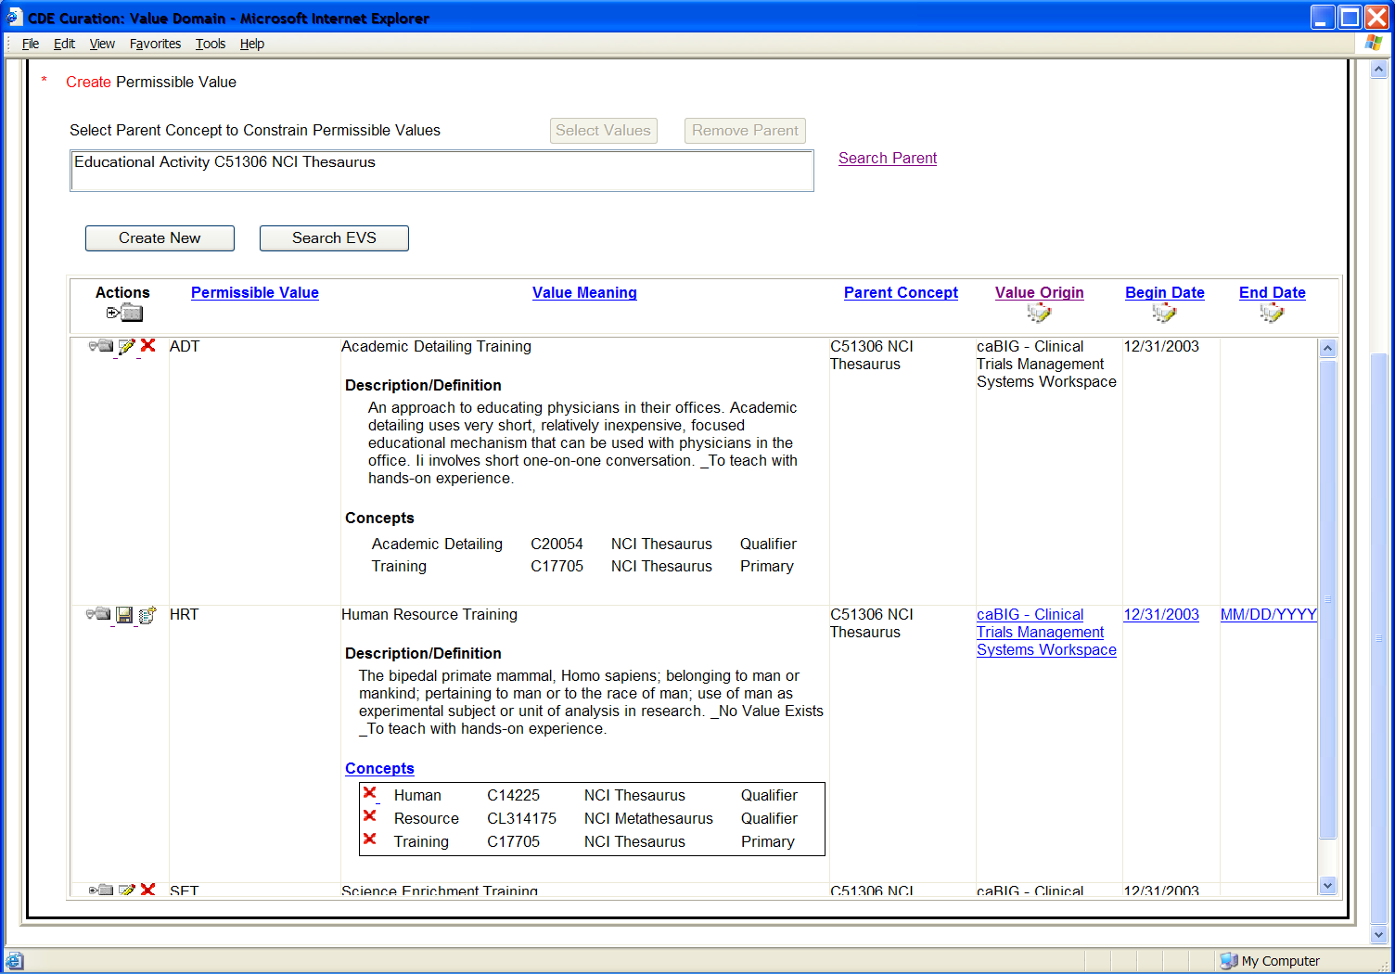

JSP/HTML
The new user interface shown above will be contained in PermissibleValue.jsp. The Permissible Value information will continue to appear on the Create_VD.jsp and Edit_VD.jsp pages, however, editing will forward to the new page above.

Servlet
The Curation Tool is deployed on JBoss as cdecurate.war.

Error Handling
Should an error be sent to the user interface, a message box appears containing appropriate text.

Security Issues
The Curation Tool uses the same database security access in caCORE 3.1.

Performance
Search performance is directly related to the values and options selected by the user for the search. The most common term search is optimized to return with results in a reasonable time. Editing and display of Permissible Values and Value Meanings are optimized by only transmitting the data needed by the page.

Internationalization
N/A

Installation / Packaging
Established installation, packaging and distribution paradigms are used via GForge. The Installation Guide provides details.

Migration
N/A

Documentation Considerations
Online help and code comments will be updated appropriately.

Unit Testing

During development, the code is traced with a debugger and the logger report level is set to DEBUG. Prior to deployment, the test driver in the gov.nih.nci.cadsr.cdecurate.test package is executed. Once deployed the user interface is used to run various features.

Test Guidelines
The Control XML file should have new data for testing create new Value Meaning. The process log should be monitored for any unexpected content noted via trace messages.

Test Cases
Test Cases are taken from the Use Cases documented separately in “Value Meaning 3.2 Use Cases.doc.”

Test Results
The test cases should successfully execute without error or exception. All data changes are stored in the caDSR under the TEST Context and can be viewed from the user interface.
DOCUMENT CONTROL
Change History
Content changes to this document from the previous to the current level are indicated by revision bars (|) unless a complete rewrite is indicated.

Table 3 – Implementation Specification Document Change Log
Version/Date | Approved By | Change Description and Explanation | D - Draft  A - For Review/ Approval  R - Re-Approval, Plan of Record Change
08/10/06 | Sumana Hegde | Original Draft | Draft
08/23/06 | Larry Hebel | Review and inspection edits | Draft
Note: If this document has been inspected, please indicate the inspection date that each version is based on in the “Change Description and Explanation” area. Entries in this log must be maintained for at least 3 years.

DOCUMENT APPROVAL
Approvers List
The individuals listed in this section constitute the approvers list for the Integration Test Plan document. Formal approval must be received from all approvers prior to the initiation of the next steps in the process.

Table 4 - Test Plan Approvers List
Title | Name
Project Manager | name
Development Manager | name

Reviewers List
The individuals listed in this section constitute the reviewers list for the Master Test Plan document. Formal approval is not required from the reviewers; however, it is desirable to have all reviewers review and comment on the document. Reviewers may choose to concentrate on reviewing only those sections that are in their area of responsibility, rather than the entire document.

Table 5 - Test Plan Reviewers List
Title | Name
Solutions Manager | name
Project Manager | name
Test Manager | name
Test Engineer | name
Development Manager | name
Technical Writer | name
Client Support Analyst | name
Internationalization Lead | name
DBA | name
Developer | name
Developer | name

END OF DOCUMENT

